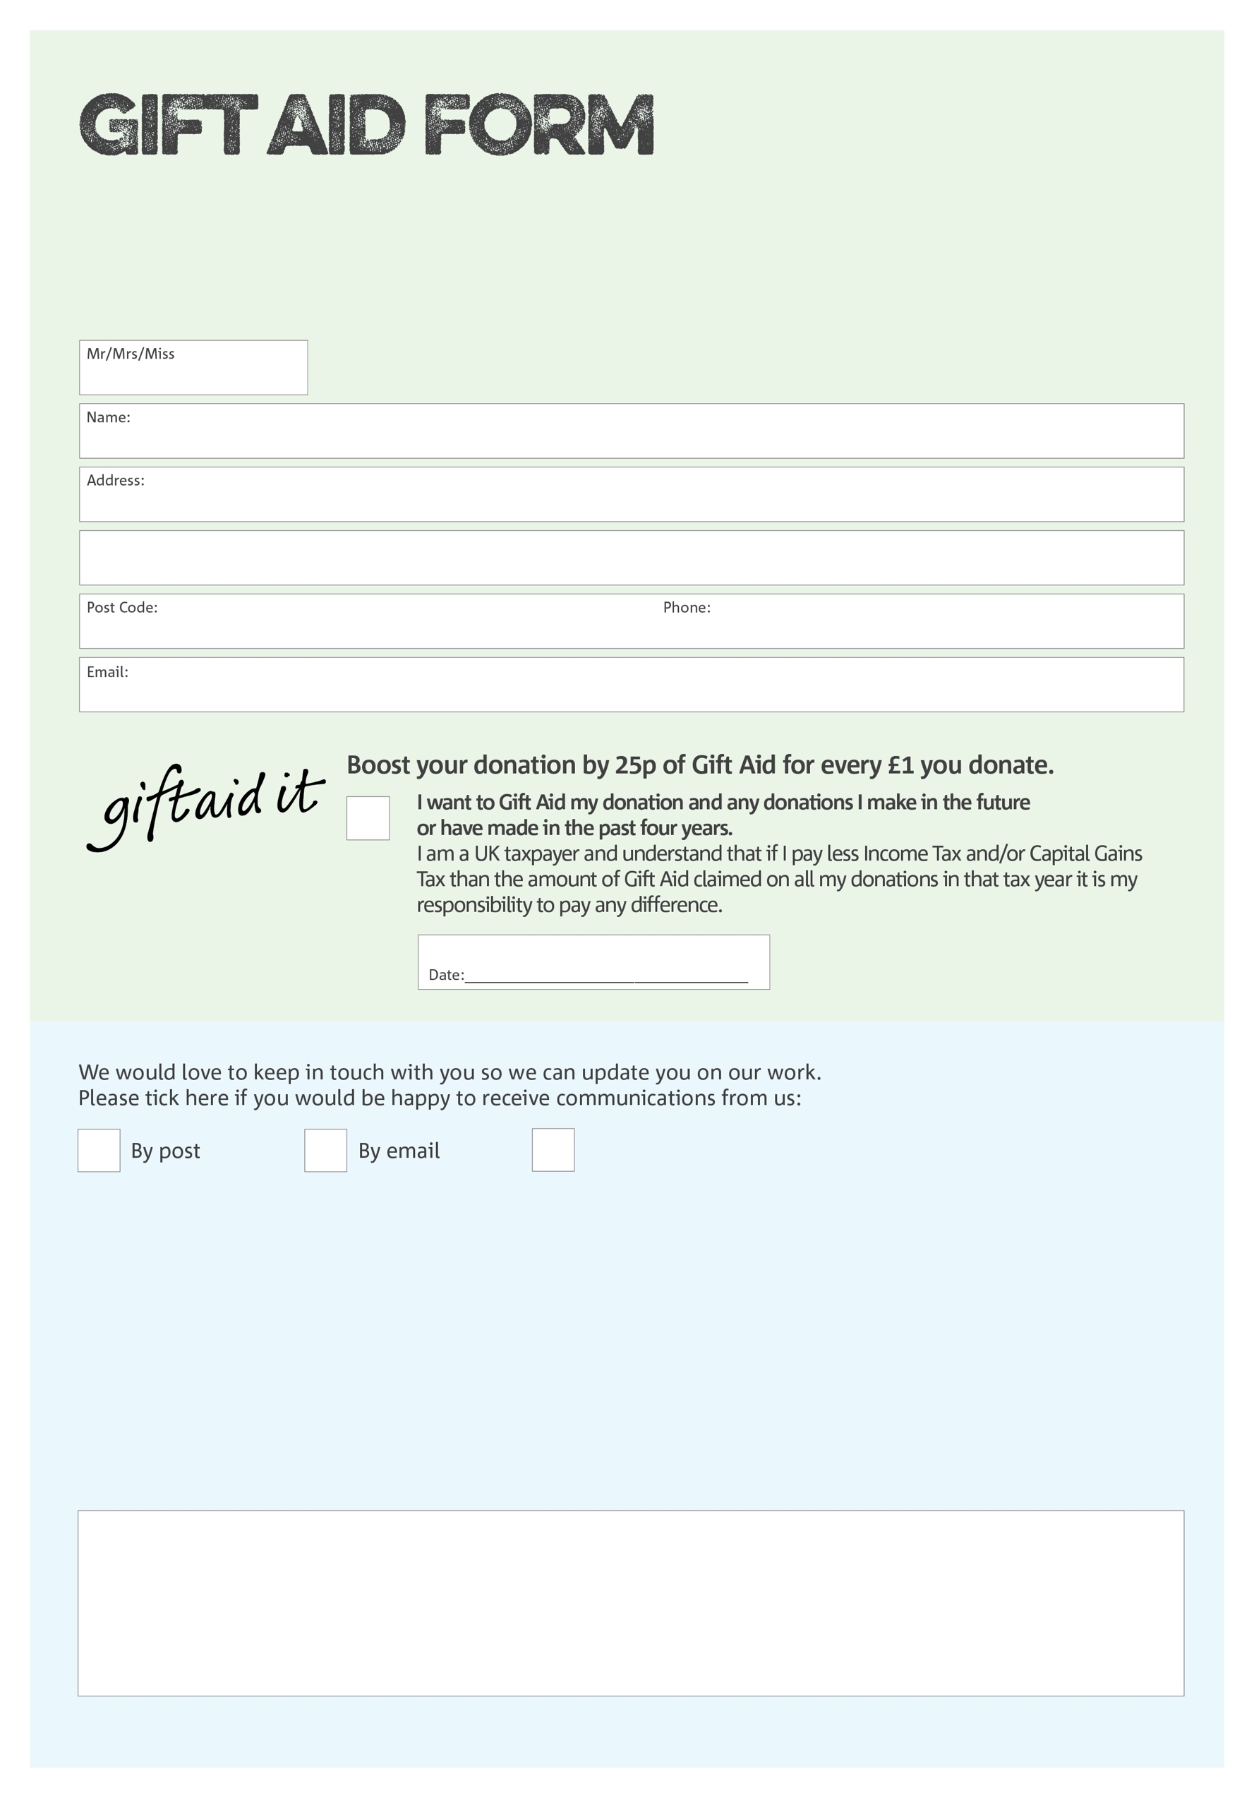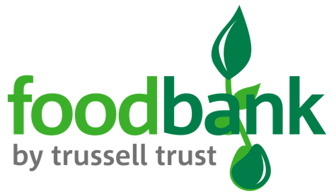

By filling in this form Cheadle and District Foodbank will receive an extra 25p for every £1 you give at no extra cost to you. Thank you!

You can change your preferences any time by contacting us on 07902 835158 or emailing us at pm@cheadledistrict.foodbank.org.uk

I do not wish to receive future communications from Cheadle and District Foodbank

**Data protection**

Cheadle and District Foodbank is committed to protecting your privacy and will process your personal data in accordance with the Data Protection Act 1998. Cheadle and District Foodbank collects information to keep in touch with you and supply you with information relating to our work. Cheadle and District Foodbank will never sell or pass your details to anyone who isn’t directly working on our behalf.

We would love to know why you have chosen to donate to Cheadle and District Foodbank. If you would like to share your motivation let us know below:

Charity Number 1156477. Registered in England and Wales